Neo4j provides a database of the results of the implementation of our paper on 2015-4-11 17:00- 20:00. The database is built according to our paper methodology. The following data attempts were obtained through Neorj Browser Cpyher statements to demonstrate the capabilities of the database model.

1. expression of connection between taxicabs states

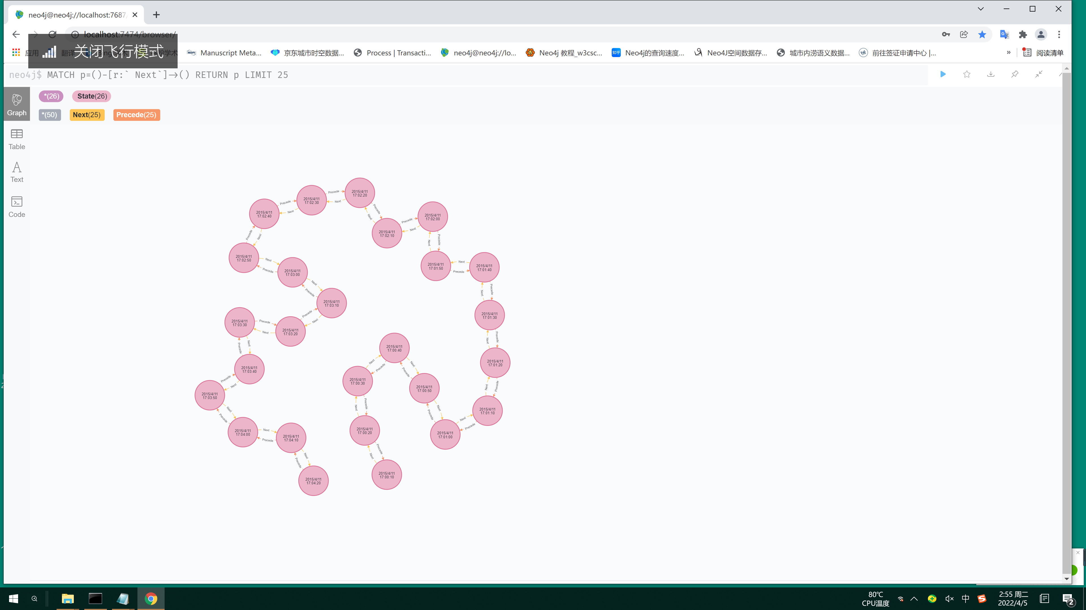

Figure 1 Organization of the taxicab state

1. The inclusion relationship between the grid and the taxicab state

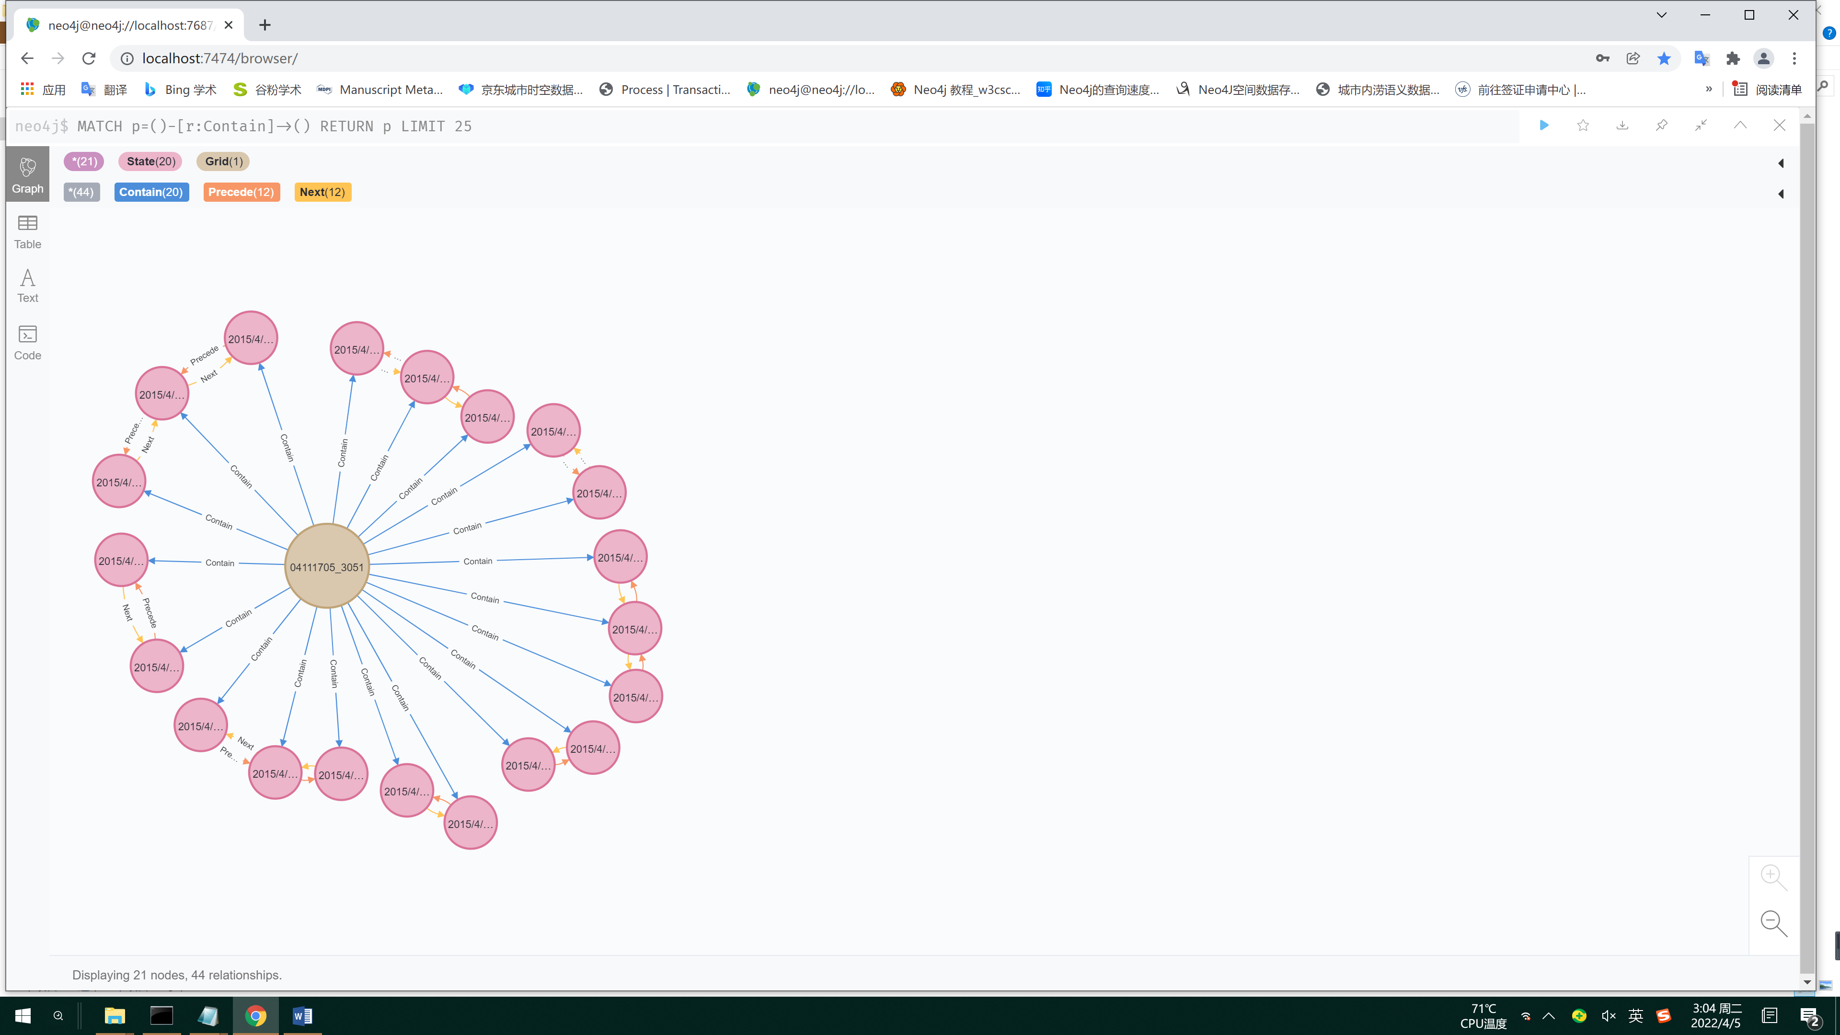

Figure 2 Taxi states are included in the grid

1. Process contains the taxicab state

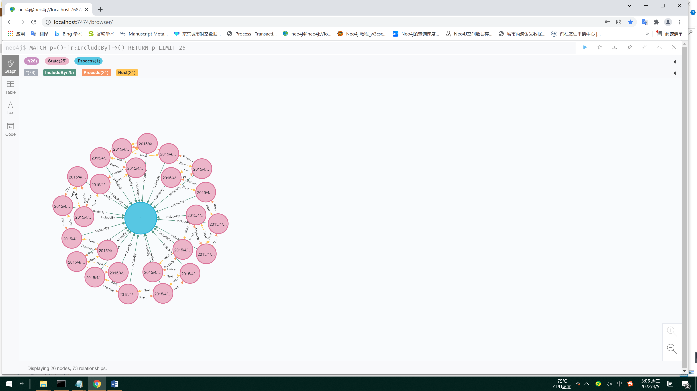

Figure 3 Process contains the taxicab state

1. Data organization of the congestion model.

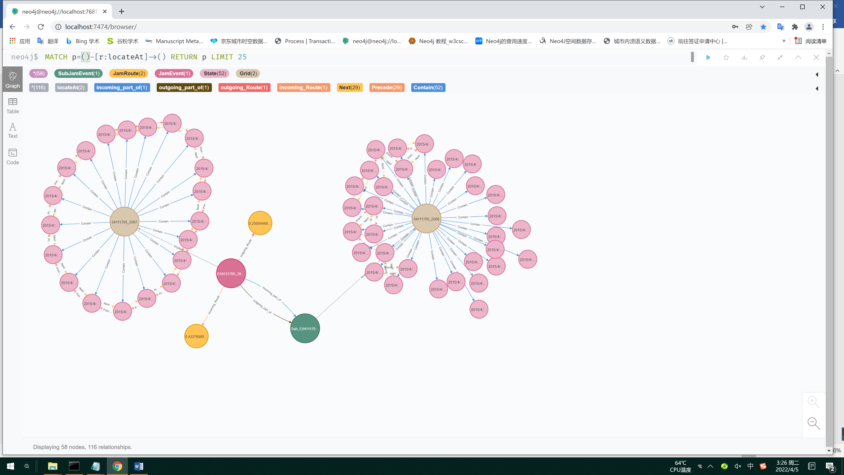

Figure 4 Example of the congestion model. The core congestion area contains a secondary congestion grid. It is known from the fact that both the incoming and outgoing routes of the congestion zone contain green sub-congestion zones that the congestion zone in the figure is two-way congestion. The figure also shows the continuous status of vehicles in the core congestion zone and the status of vehicles passing through the secondary congestion zone at different times.

1. The model contains a total number of ten million nodes and relationships.

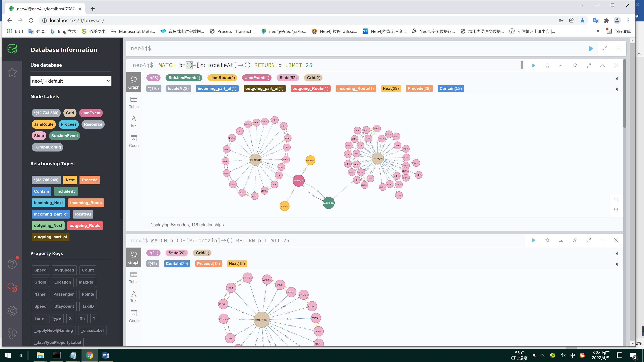

Figure 5 Details of the nodes and relationships of the model

The application and reasoning of the model is detailed in the query reasoning statements provided in the paper, and the database model system provides fast retrieval and querying